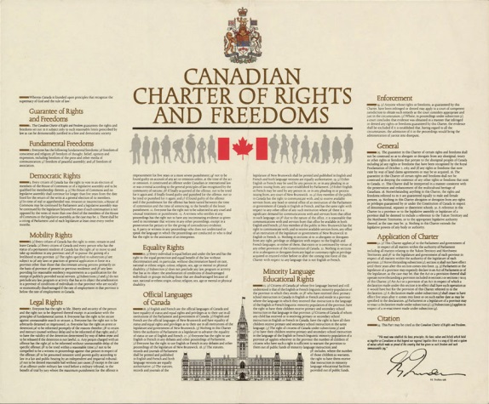
“I have my rights! This is a free country!” Have you ever heard anyone say something like that? When people talk about rights and freedoms, they’re really talking about governance: the rules that describe what government can do with its power. They’re saying that government power can only go so far — up to the point where it limits the choices you or any individual can make. If government power goes beyond that point, there has to be a reason, based on the values we hold as a society. In Canada, the rights and freedoms of individuals are stated in the Charter of Rights and Freedoms.
What is the Charter of Rights and Freedoms?
• The Charter of Rights and Freedoms is part of Canada’s constitution. The constitution sets out the framework for how Canada is to be governed.
• The constitution is the highest law of Canada. All other laws must be consistent with it.
• Before the Charter, Canada’s provincial and federal government had — and still have — a variety of laws about individual rights. The Charter created constitutional protections for individual rights and freedoms, which apply to laws and governments across Canada.
• With the Charter, Canadians can challenge in court laws that restrict their rights. The judicial branch makes decisions about these challenges by interpreting how to apply the Charter. It strikes down laws that restrict rights in an unjustified way.
• The Charter says that Canada’s government is justified in restricting rights, if the restrictions are necessary to maintain Canada as a free and democratic society. Why might Canadians have different views about what restrictions are justified?
ASSIGNMENT

- Examine the rights and freedoms of individuals listed in the Charter. What responsibilities do you believe individuals have because of these rights? Complete a T-chart like the one below.
Rights and Freedoms | Responsibilities
-Democratic rights | -The responsibility to respect the results of elections.  -The responsibility to….

- When was the Canadian Charter of Rights and Freedoms made law in Canada?
- What is the main difference between an ‘individual’ and a ‘citizen’?
- Your opinion/reflection: What do you consider your most important rights under the charter? What rights would you add? (write at least ½ page)

Does not meet expectations | Success criteria to meet expectations | Exceeds expectations
 | Demonstrates a knowledge of charter rights and an understanding of the responsibilities with specific and correct examples from the charter
 | Clearly communicates an opinion on the rights and responsibilities of a citizen

